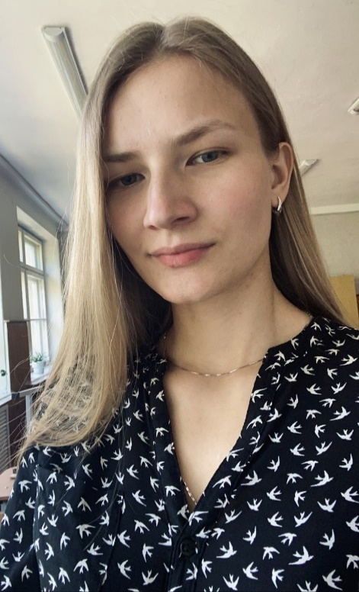**Olga Grinyova**

**Phone:** +375 (33) 601-31-74  
**E-mail:** grinyovao@list.ru /  
olgagrinyova1998@gmail.com  
**Telegram:** @olga_grinyova   
**LinkedIn:** www.linkedin.com/in/olga-grinyova

**Objective**  
  
Applying for a position of a **Manual QA Engineer**

**Summary**

I am a purposeful and responsible person who can adjust quickly to new surroundings. My qualities such as sociability, flexibility and dependability make me good at teamwork. I am well organized and detail oriented which I believe is a key to successfully managing responsibilities.  
  
  
**Skills  
  
English language:** Upper-Intermediate  
**German language:** Intermediate  
**Chinese language:** Basic  
**Test Management Systems:** TestRail  
**Bug Tracking Systems:** Jira, Azure DevOps  
**API Testing Tools:** Postman, SoupUI (basics)  
**Database Management:** MySQL  
**Tools:** Chrome DevTools

**Description:** Learning of theory and practice of functional testing such as basics of testing, bug reporting, creating of test documentation, preparing Test Results Reports, Mobile Application Testing, Web Application Testing, basics of SQL, basic knowledge and skills with Chrome DevTools, basics of Postman, basic knowledge of Bash commands, basics of HTML /CSS.

https://github.com/OlgaGrinyova

**Education**

* **2015 - 2019 - Mozyr State Pedagogical University named after I.P.Shamyakin**   
  Speciality: Foreign languages (English, German)
* **2021 – present time - Confucius Republican Institute of Sinology, BSU  
  Course:** Chinese language
* **2022 – Artsiom Rusau course on Udemy  
  Course:** QA Engineer
* **2022 - Popelyshko Natalia course on Udemy  
  Course:** QA Engineer

**Work experience**

* **August, 2019 - August, 2021 – Teacher of English**Secondary school №29, Bobruisk   
    
  ***Main responsibilities:***Creation and preparation of documentation;  
  Using modern applications and platforms for learning English (Kahoot, Quizlet, Plickers, CodaQuest, Education City).

* **September, 2021 - March, 2022 – International transport specialist**LLC "Dva Kontinenta", Minsk   
   ***Main responsibilities:***Manage operational tasks related to transportation and customs clearance;   
  Shipping documents preparation;   
  Search for the new customers and develop relationships with the current ones.

Currently, I’m focused on extending my functional testing skills that's why I use all kinds of training platforms where I put my knowledge into practice. My priority goal is to obtain a position in a company that offers a variety of challenging projects with growth potential in terms of individual and professional development.